Notes

The Chain Rule

In the previous lesson we were introduced to the power rule. It turns out that the power rule is a special case of a more general rule called the chain rule. The chain rule states that, for any function f(g(x)), where u = g(x),

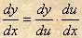

Let’s work a couple of examples to illustrate this rule.

Example 1 Find the derivative of y = (6x⁴ – 5x +2)^{3/8}.

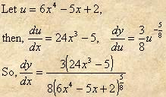

Notice that we have used rational exponents in this example. We could have used rational exponents earlier when we introduced the power rule. There are no constraints that required us to use integer exponents.

Example 2 Find the derivative of y = (4x²-1)^{-1/2}.

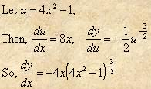

Finish out this lesson with the students working more examples, both at the board and at their desks while you provide coaching.
(McCallum)

