PROBLEM 1 : Differentiate
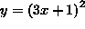
PROBLEM 2 : Differentiate
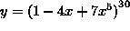.
PROBLEM 3 : Differentiate
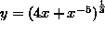
PROBLEM 4 : Differentiate
.
PROBLEM 5 : Differentiate
.
PROBLEM 6 : Differentiate
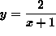
PROBLEM 7 : Differentiate
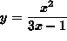.
PROBLEM 8: Differentiate
.
PROBLEM : Differentiate
.

Problem 10: Differentiate
.

